NATIONAL UNIVERSITY OF MODERN LANGUAGE ISLAMABAD
Lab2


Submitted to:
Sir Hassan Shah
Submitted by:
Zulqarnain Hassan
Roll No: …………………… SP21379
Subject: …………………… computer network
Department: ……………… BSSE-5-Afternoon
Date: ……………………… 10-11-2024

- Test the NIC of the PC - Ping 127.0.0.1 called (Loopback address)
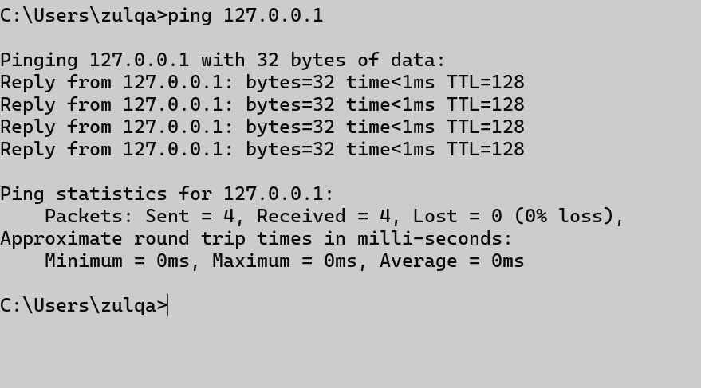

- Ping the default gateway.
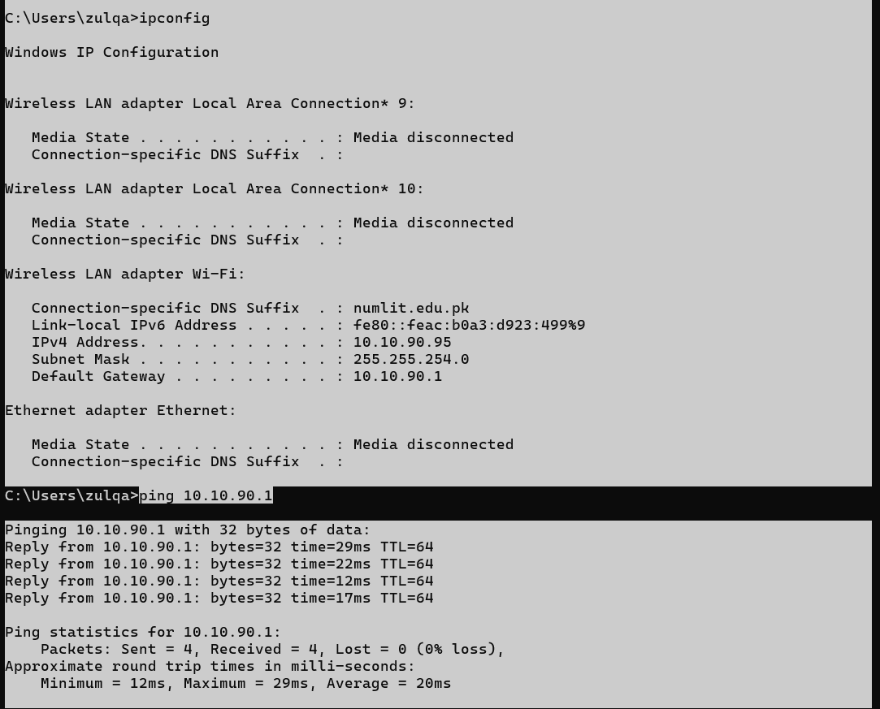

- Ping your hostname.
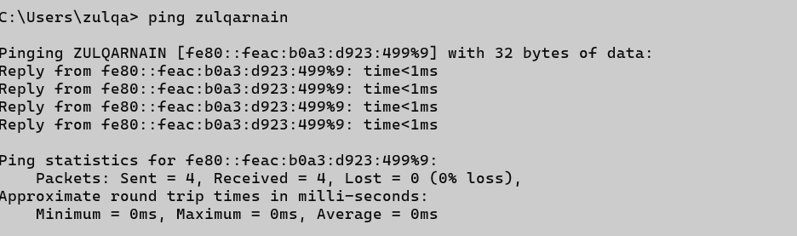

- Ping the DNS server(s)

I get a positive reachability result.

- How to obtain the following network configuration on your computer.
Host Name:
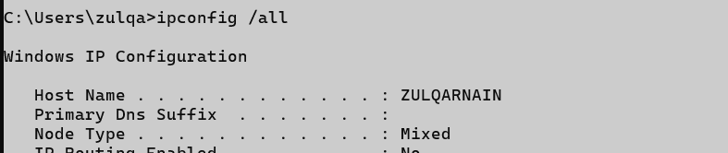
MAC Address:
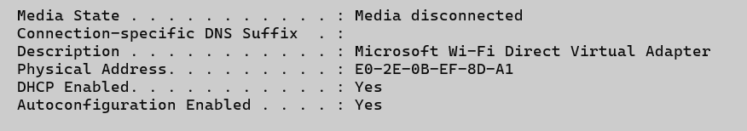
IP Address:
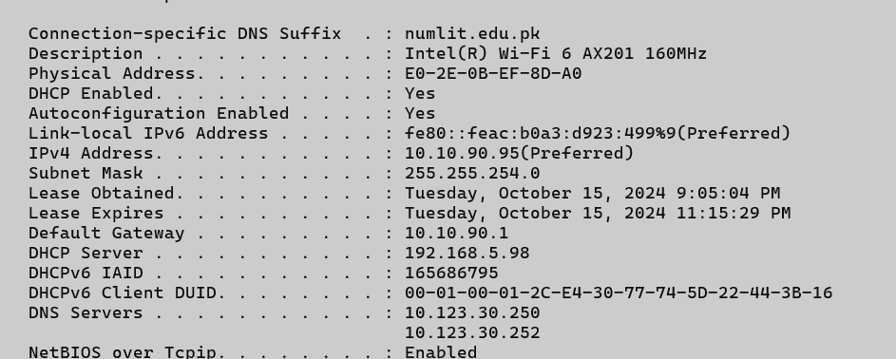
Subnet Mask:

Default Gateway:

DHCP Servers:

- Open a web browser and visit the following website: http://whatismyipaddress.com/
Is the reported IP address consistent with that obtained by ipconfig? If not, why?
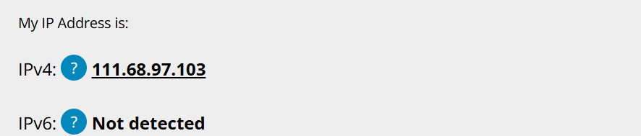

The reported IP address through above address is different from obtained by ipconfig because, The IP address we see in the ipconfig output is our local (private) IP address assigned by our router.
The IP address shown on the website is our public IP address, which is the address assigned to our network by our Internet Service Provider (ISP). This is the address that other devices on the internet see when we connect to them.

- Perform ARP and report dynamic addresses.
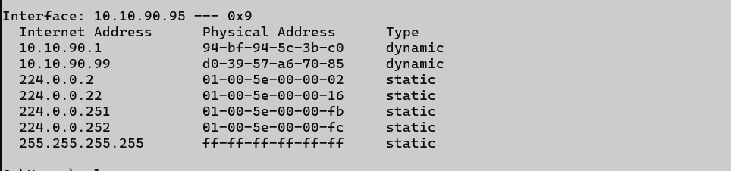

- Identify the computer names of the dynamic addresses and perform ARP using computer names.

